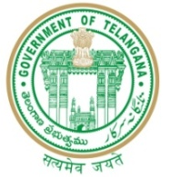

GOVERNMENT OF TELANGANA
TELANGANA TRIBAL WELFARE RESIDENTIAL DEGREE COLLEGE (GIRLS), MAHABUBABAD: MAHABUBABAD-DIST
https://www.ttwrdcs.ac.in/Mahabubabad
E-Mail Id:ttwrdcgirls.mahabubabad@gmail.com Cell No: 7901097695

Extension Lecture
Date : 03/10/2023
Venue : TTWRDC (G) - MHBD
Participants : 31
Department of statistics (UG) organized a guest lecture as a part of statistics course for II B.SC (MSCS) students on Friday 3rd October 2023. The session was on the topic "Correlation."
The guest speaker for the session was Dr. S. Ramesh Sir (Assistant professor) of commerce SR &BGNR College (A), Khammam.
Sir, delivered introduction of correlation, types, formulas and examples related to topic very effective manner ova students lean so many things i.e.; how we have to use correlation in real life situations.
Over all the session was completed smooth and effective manner.
